**T3 Case Problem Review: Meet Our Coaches**

**Summary**

Alison has created another page for the Tri and Succeed Sports website providing biographies of the coaches at the club.

She has already written the page content, acquired image files, and created a style sheet for the page layout. Your job will be to finish the design of the page by developing a style sheet for the page’s color scheme and typography.

A preview of the page you’ll design is shown below:

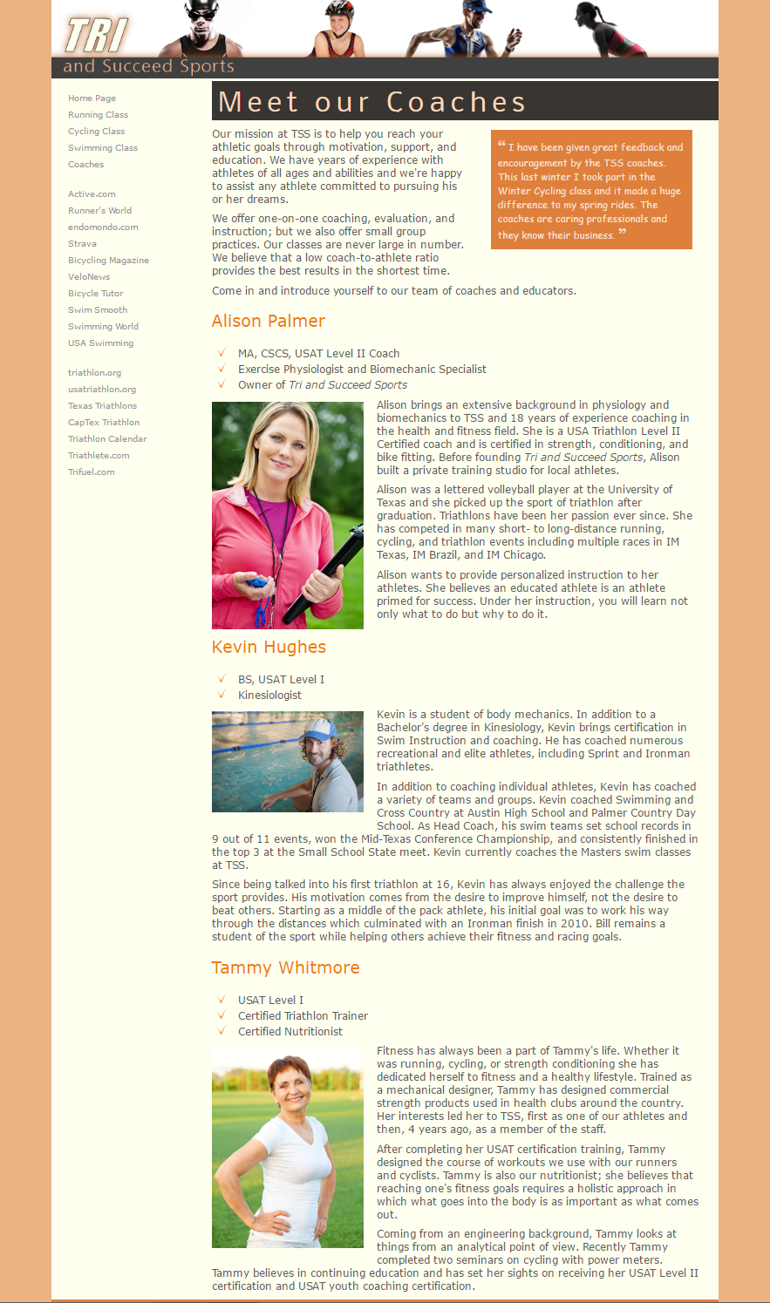

**1.) Document Setup**

Using your editor, open the **cw_class.html** and **cw_styles.css** files. Enter **your name** and **the date** in the comment section of each file.

Go to the **cw_class.html** file in your HTML editor. Within the document head, create a link to the **cw_styles.css** style sheet file.

## **2.) Setting a Font**

Using the Google Fonts website, locate the Limelight font. Copy the code for the link element to use this font and paste the copied code to the document head in the cw_class.html file.

Study the content and structure of the cw_class.html file. Your file file will be saved for you.

Go to the **cw_styles.css** file in your editor. At the top of the file, define the character encoding as utf-8.

On the next line, use the @import rule to import the contents of the cw_layout.css file into the style sheet.

## **3.) Structural Styles**

Go to the Structural Styles section. Within that section create a style rule to set the background color of the browser window to rgb(151, 151, 151).

Create a style rule to set the background color of the page body to rgb(180, 180, 223) and set the body text to the font stack: Verdana, Geneva, sans-serif.

Display all h1 and h2 headings with normal weight.

Create a style rule for every hypertext link nested within a navigation list that removes underlining from the text.

Create a style rule for the footer element that sets the text color to white and the background color to rgb(101, 101, 101). Set the font size to 0.8em. Horizontally center the footer text, and set the top/bottom padding space to 1 pixel.

## **4.) Body Header Styles**

Next, you’ll format the body header that displays the name of the university. Go to the Body Header Styles section and, for the body > header selector, create a style rule that sets the background color to rgb(97, 97, 211).

The university name is stored in an h1 heading. Create a style rule for the h1 heading that is a direct child of the body header that sets the font size to 4vw with the color value rgba(255, 255, 255, 0.8). Display the text with the font stack: Limelight, cursive. Set the margin space to 0 pixels and the top padding to 10 pixels and the right padding to 20 pixels.

The last word of the h1 heading text is enclosed within a spanelement. Create a style rule for the span element nested within the h1 heading that is nested within the body header, setting the text color to rgba(255, 255, 255, 0.4).

## **5.) Navigation Styles**

Go the Navigation Styles section. In this section, you format the navigation list that has the ID *mainLinks*. For hypertext links within this navigation list, set the top and bottom padding space to 5 pixels.

For previously visited and unvisited links within the mainLinks navigation list, create a style rule that displays the hypertext links in a white font.

For hovered or active links within the mainLinks navigation list, create a style rule that displays the hypertext links in white with an opacity of 0.8 and set the background color to the value rgba(51, 51, 51, 0.5).

## **6.) Outline Styles**

Go to the Outline Styles section. In this section, you’ll format the course outline that appears on the page’s left column. The navigation list in this outline has the ID *outline*. Create a style rule for this navigation list that sets the text color to rgb(51, 51, 51) and the font size to 0.8em.

Horizontally center the h1 headings within the outline navigation list.

For the first level ol elements that are a direct child of the outline navigation list, create a style rule that sets the line height to 2em, the top/bottom margin to 0 pixels and the left/right margin to 5 pixels. Display the list marker as an upper-case Roman numeral.

Display the second level of ol elements nested within the outline navigation list with an upper-case letter as the list marker.

Display all previously visited and unvisited links in the outline navigation list using the color value rgb(101, 101, 101).

Display hovered and active links in the outline navigation list using the color value rgb(97, 97, 211) with the text underlined.

## **7.) Section Styles**

Go to the Section Styles section. In this section, format the description of the course. Create a style rule that sets the background color of the section element to rgb(220, 220, 220).

Format the heading of this section by creating a style rule for the section header h1 selector that sets the font size of 2.2em and the left padding space to 10 pixels.

## **8.) Article Styles**

Go to the Article Styles section and create a style rule for h2 headings within the article element that sets the font size to 1.4em.

Display the first letter of the first paragraph within the article element with a font size of 2em and vertically aligned with the baseline of the surrounding text.  
(*Hint*: Use thefirst-of-type pseudo-class and the first-letter pseudo-element.)

## **9.) Aside Styles**

Information about Peter Craft has been placed in an asideelement. Go to the Aside Styles section and create a style rule that sets the font size of text in the aside element to 0.9em.

For h1 headings nested within the aside element, create a style rule that sets the font size to 1.4em and horizontally centers the text.

**10.) Review Webpage**

Click the **Build Website** button at the bottom of your screen. Next open the **cw_class.html** file and verify that the appearance of the page resembles that shown in *Figure 2-56* in a previous step.

Confirm that when you change the width of the browser window, the size of the page heading text changes in response to setting the heading text using the vw unit.

Review the webpage you have created on the right side of the screen.

**11.) Validate**

You can use the [W3C HTML Validator](https://validator.w3.org/#validate_by_input) to ensure that your HTML files adhere to World Wide Web (W3) standards. This also helps improve the readability of your HTML files, making them easier to work with.